1.INTRODUCTION
Power system Stability has always been a great concern from its developmental phase. Power System stability refers to the system's ability to return to normal or stable operation after having been subjected to some form of disturbance. In practical operations, power systems inevitably experience various disturbances such as short-circuit faults, line disconnections, and the integration or disconnection of large-capacity loads. These disturbances frequently lead to widespread blackouts globally. Power system Stability has been classified into various types as Voltage Stability, Frequency Stability, Resonance Stability and Angle Stability (Transient Stability).
Our project is related to Angle Stability during large disturbance i.e Transient Stability. Transient stability involves the response to large disturbances, which may cause rather large changes in rotor speeds, power angles, and power transfers. It is a fast phenomenon usually evident within a few seconds.
Transient stability assessment methodologies are broadly classified into three main types:
- Simulation Methods (Time-Domain Simulation)
- Direct Methods (Energy Function based)
- Data-Driven Methods (Machine Learning based)
Our work focuses on the Direct Method, which leverages the Transient Energy Function (TEF) integrated with computational techniques to determine system stability quickly and accurately. The TEF framework provides a robust metric for assessing the system's total energy (kinetic and potential). To assess stability, this calculated energy must be compared against a critical energy limit (Vcr), which represents the maximum energy the system can absorb without losing synchronism. This critical threshold is accurately determined offline using the Boundary of Controlling Unstable Equilibrium Point (BCU) methodology.
This project is built upon the real-time stability prediction and control framework proposed by Pratyasa Bhui and Nilanjan Senroy [1]. Their hybrid method combines an offline database of stability boundaries (computed using the BCU technique) with an online assessment driven by PMU data. Following the detection of an unstable disturbance, the system determines the required emergency control action, typically generation shedding.
A critical step in this control phase is the need to predict the generator states (rotor angle and speed) at a future time-specifically, the moment the control signal (e.g., generation shedding) is expected to take effect. This prediction compensates for the inherent computational and communication delay (Td) in the control loop. The base methodology achieves this prediction using cubic and quadratic curve fitting over a small window of post-fault data.
However, the non-linear nature of power system swings especially during the first, critical swing limits the predictive accuracy of simple polynomials. To enhance the reliability and precision of the emergency control action, we propose replacing the conventional curve fitting technique with a Long Short-Term Memory (LSTM) neural network. LSTMs are inherently capable of learning complex, time-dependent, and non-linear patterns within time-series data. Once trained on a comprehensive dataset of fault trajectories, the LSTM model can provide significantly more accurate prediction of generator angle and speed at the point of control actuation, thereby improving the estimation of the required generation shedding and minimizing the risk of unnecessary or insufficient control action.
This enhancement aims to deliver an ultra-fast, accurate, and reliable framework for transient stability assessment and emergency control on complex systems, demonstrated using the IEEE 39-Bus test system.

2.LITERATURE REVIEW
Transient stability refers to the power system's ability to remain in synchronism following a large, sudden disturbance, such as a severe fault or the loss of a major transmission line. The assessment of transient stability is critical for preventing widespread cascading failures and blackouts, necessitating methodologies that are both accurate and rapid enough to facilitate emergency control actions.

2.1. Traditional Transient Stability Assessment Methods
Historically, power system stability has been analyzed using two main approaches:

2.1.1. Time-Domain Simulation (TDS)
TDS involves the numerical integration of the system's differential and algebraic equations over time, providing the most detailed and accurate representation of rotor angle and speed trajectories [5]. However, the computational complexity of TDS renders it too slow for real-time applications. For large-scale power grids, the time required to complete a full simulation often exceeds the critical time window available for making and executing emergency control decisions.

2.1.2. Direct Methods and the Transient Energy Function (TEF)
To overcome the speed limitation of TDS, Direct Methods were developed. These methods rely on the Transient Energy Function (TEF), a single scalar function that describes the system's total energy (kinetic and potential) for a post fault system[4].

2.2. The Transient Energy Function

Power system undergoing disturbance can be modeled by set of three differential equation as given in [5] as:
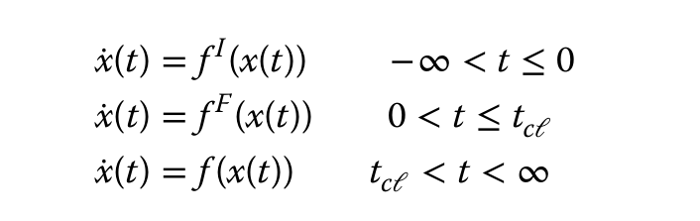

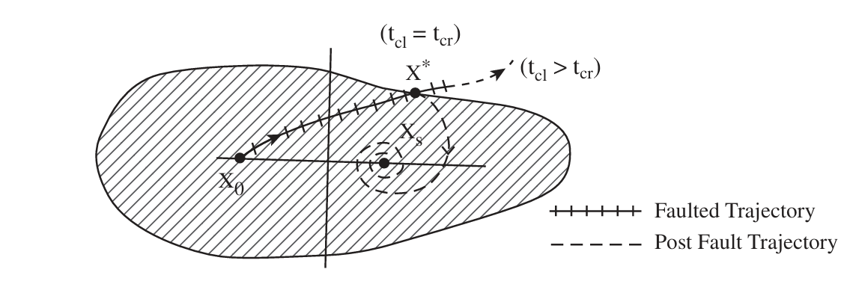
Fig 1: Region of attraction and computation of tcr.

The swing equation for multi-machine system is given by [5]:
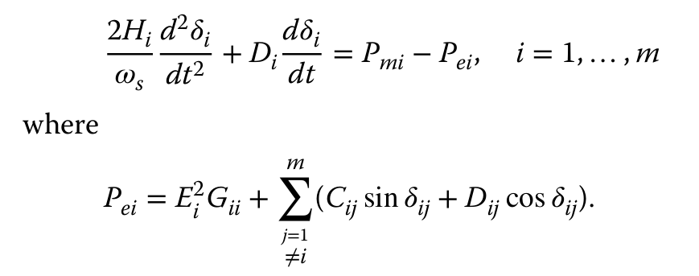

Energy function is given by [5]:
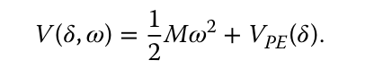

The energy function of multimachine system is given by [5]:
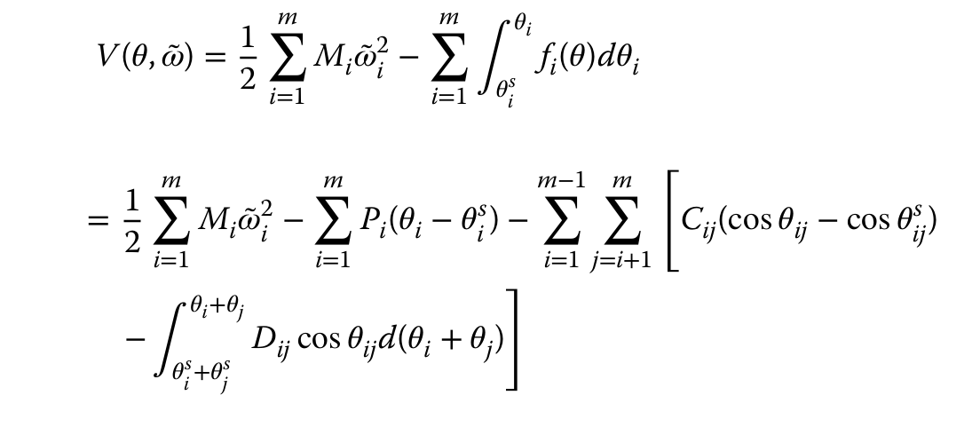

Transient Energy is the total energy in the power system after the fault is cleared. It is the sum of potential and kinetic energy in the system for a post fault system.

The Transient energy function for the post fault system is described by following function[1]:
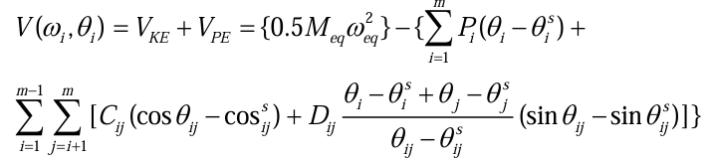

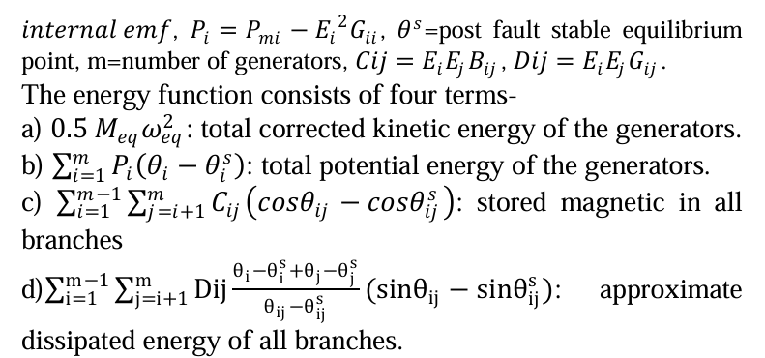
The stability determination within the TEF method is based on a straightforward comparison: the system is stable if the energy gained during the fault, V_{cl} is less than the critical energy limit, Vcr. i.e. Vcl< Vcr
The swing equation can be modeled as below for further analysis[1]:
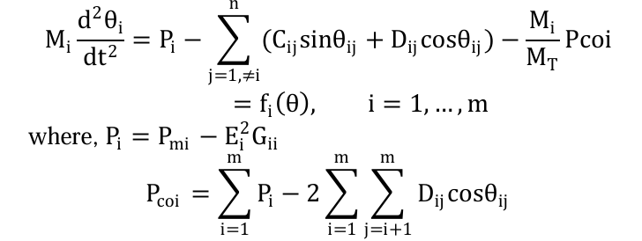

Potential Energy Boundary Surface (PEBS): An initial, faster approximation method that estimates the critical energy by tracking the potential energy along the fault trajectory. While quick, PEBS often provides an inaccurate estimate of the true stability limit.

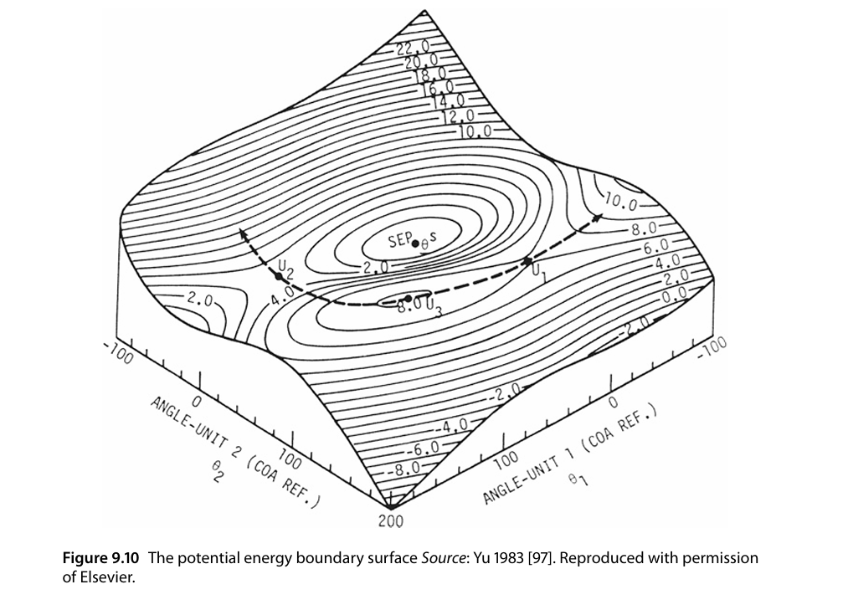
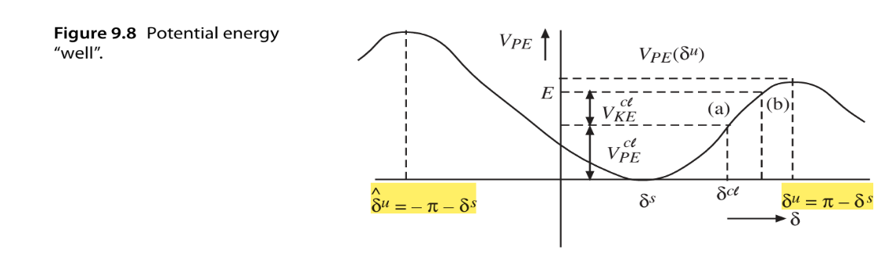
Fig 3: PEBS
Fig 2: Potential Energy “well”

Boundary of Controlling Unstable Equilibrium Point (BCU):The BCU methodology is the high-accuracy technique used to rigorously locate the Controlling Unstable Equilibrium Point (CUEP). The potential energy at the CUEP defines the true Vcr for a specific fault [4]. The BCU method is essential for obtaining a reliable stability threshold.

2.3. Hybrid Framework for Real-Time Control (The Base Paper)
Our project is founded on the real-time prediction and control framework proposed by Bhui and Senroy [1]. This hybrid methodology effectively addresses the computational hurdles of the Direct Method to enable quick, real-time stability assessment:

2.3.1. BCU-TEF Hybrid Structure
The framework operates in two modes:
- Offline Computation: The highly accurate BCU method is used offline to compute Vcr and critical clearing time Tcr for various fault locations and system topologies. This helps to find the correct MOD (Mode of Disturbance). Corresponding to each MOD Normalized kinetic energy Vector is calculated which acts as signature for online Computation. This data is stored in a look-up table.
- Online Assessment: When an actual fault occurs, real-time data from Phasor Measurement Units (PMUs) are used to quickly identify the corresponding MOD from the look-up table and determine the stability margin (Vcr - Vcl) with high confidence followed by proper control action [1].

2.3.2. The Curve Fitting Bottleneck
The effectiveness of the framework relies on the ability to take immediate emergency control action (e.g., generation shedding) if the system is found to be unstable. However, an inherent computational and communication delay (Td) exists between the moment instability is detected and the moment the control action is physically executed.
To compensate for this delay, the base paper requires the prediction of the generator's state (rotor angle and speed ) at the future control actuation time,Tcl + Td. The original method employs cubic and quadratic curve fitting over a small post-fault time window to extrapolate the generator states.
This reliance on polynomial curve fitting constitutes the primary bottleneck in the system's predictive accuracy. The non-linear, oscillatory dynamics of the power system's first swing are poorly approximated by simple polynomial functions, leading to prediction errors in angle and speed. Since kinetic energy (Vke) is proportional to the square of speed w², small errors in the speed prediction are amplified, compromising the accuracy of the final generation shedding calculation.

2.4. Machine Learning for Enhanced Time Series Prediction
To resolve the predictive limitations of polynomial fitting, this project leverages advancements in deep learning for time series data.

2.4.1. Long Short-Term Memory (LSTM) Networks
Long Short-Term Memory (LSTM) networks are a specialized architecture of Recurrent Neural Networks (RNNs) designed specifically to model complex, sequential data by overcoming the vanishing gradient problem [3]. Using internal memory cells and gating mechanisms (input, forget, and output gates), LSTMs excel at learning long-term dependencies and hidden non-linear relationships within a time series. The internal structure of the LSTM can be given as below.

2.4.2. Justification for LSTM Integration
Given the need to accurately forecast the oscillatory and transient behavior of generator angles and speeds, the LSTM model offers a theoretically superior solution to curve fitting. Once trained on a comprehensive dataset of fault trajectories, the LSTM can model the non-linear swing dynamics with high fidelity. This leads to a more precise prediction of the generator state at the control actuation time, directly translating into a more accurate estimation of the required generation shedding amount. LSTMs are already successfully employed in the power domain for other time-series tasks, such as load and renewable generation forecasting [2].
By integrating the LSTM prediction engine into the control phase of the TEF framework, we aim to significantly improve the reliability and precision of emergency stability control in modern power systems.

3.PROBLEM STATEMENT, OBJECTIVES, SCOPE & LIMITATION

3.1. Problem Statement
The Transient Energy Function (TEF) framework, particularly when combined with the Boundary of Controlling Unstable Equilibrium Point (BCU) methodology, provides a fast and reliable solution for real-time transient stability assessment. However, the subsequent emergency control action (such as generation shedding) is susceptible to computational and communication delay (Td), typically ranging from 100 ms to 300 ms, between the moment instability is detected and the control command is executed.
To account for this delay, the base methodology proposed by Bhui and Senroy [1] relies on predicting the generator states (rotor angle and speed) at the future time of control actuation. This prediction is achieved using cubic and quadratic curve fitting based on a small window of post-fault data. The core problem this project addresses is the inherent inaccuracy of polynomial curve fitting in modeling the non-linear, oscillatory dynamics of the power system's first swing.
The primary challenge is to develop a highly accurate, real-time-capable state prediction module that minimizes forecast error during the critical control delay period, ensuring optimal sizing of the emergency control action.

3.2. Project Objectives
The primary objectives of this project are derived from the need to enhance the predictive accuracy of the control module within the established TEF framework:
- To develop and implement the core Transient Energy Function (TEF) framework and the BCU-based stability assessment methodology as described in the base paper for stability assessment.
- To use Long Short-Term Memory (LSTM) Neural Network Model for accurate and real-time prediction of generator rotor angles and speeds during the control delay period.
- To integrate the enhanced LSTM based TEF prediction into the generation shedding calculation module.
- To demonstrate the applicability, performance and improved accuracy of the enhanced TEF-based control method using the IEEE 39-bus test system.

3.3. Scope of the Project
- System Model: The project focuses on the transient stability analysis of the IEEE 39-bus New England Test System.
- Core Focus: The project's novel contribution is strictly confined to the enhancement of the prediction module (replacing the curve fitting method with LSTM) within the existing control calculation framework.
- Control Action: The emergency control action under consideration is selective generation shedding applied to the most unstable generators.

3.4. Limitations
The following inherent limitations are acknowledged in the execution and applicability of this project:
- Classical Model Assumption: Generator Model for the TEF is a classical model for simplicity.
- Network Model: Internal node model of the network is used in the project.
- Data Dependency: The LSTM model is a data-driven approach. Its superior performance is critically dependent on the quality, quantity, and comprehensiveness of the training data (i.e., the simulated fault trajectories). The model may perform poorly on fault types or system conditions not represented in the training set.
- Real-Time PMU Data: The online assessment assumes the availability of synchronized, high-speed, high-quality data from Phasor Measurement Units (PMUs) to feed the TEF and LSTM.

4.METHODOLOGY AND RELATED THEORY
1. Offline Computation/Look-up Table :
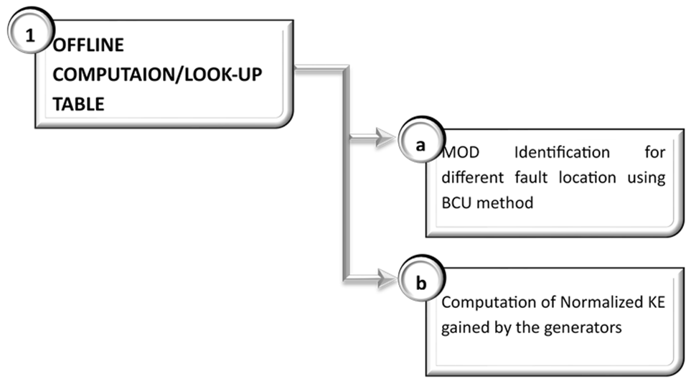
Fig 4: Block Diagram of Offline Computation

a. MOD Identification for different fault location
MOD is obtained using BCU Method:
- Tcr is calculated using BCU method.
- Time domain simulation is done for a fault duration slightly higher than Tcr.
- Detection of peak of the potential energy and generator ranking descending order of the angles.
- Taking top machines as MOD and calculate CCT using MOD technique.
- machine groups with minimum error between time domain simulating CCT and TEF CCT taken as the MOD.
b. Computation of normalized KE gained by the generators:
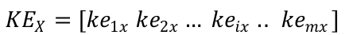
Kinetic energy Vector is given by:

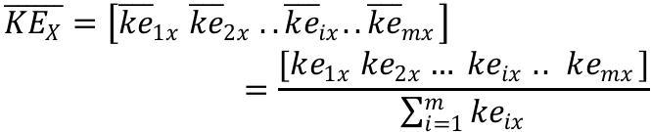
Normalized Kinetic Energy Vector is given by:

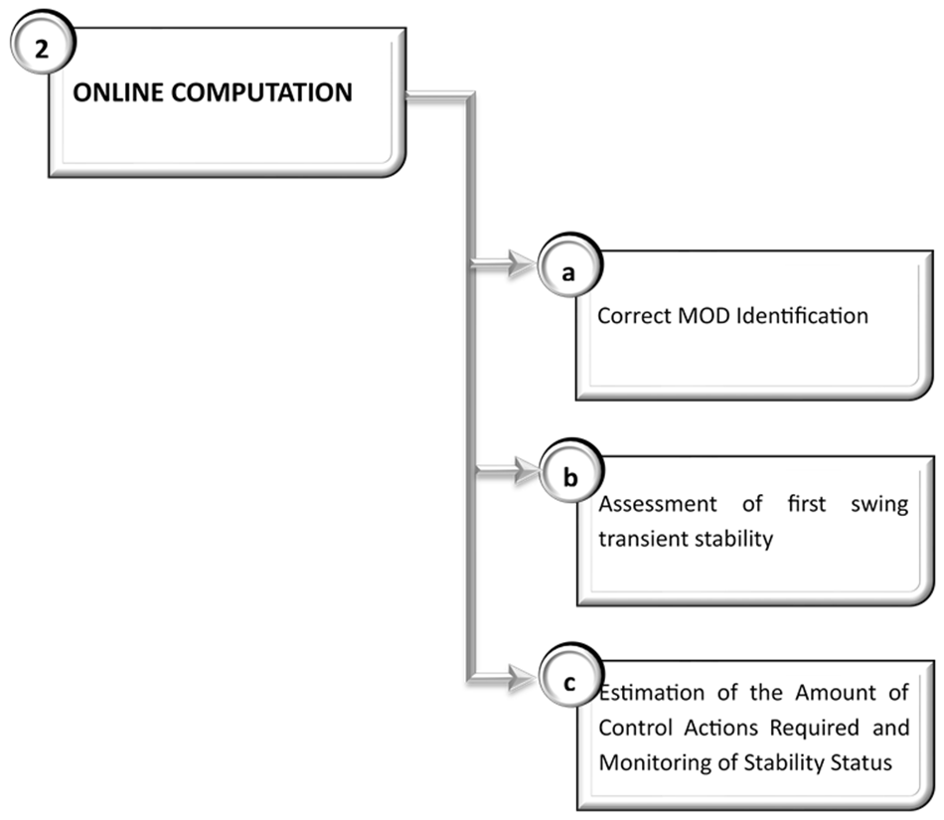
2.Online Computation
Fig 5: Block Diagram of Online Computation

- Correct Mode Identification
Step 1 : Calculation of KE
Step 2 : Ranking of Probable MODs
Step 3 : Calculation of Post-Fault SEP
Step 4 : Calculation of CUEP
Step 5 : Identification of correct MOD
- Assessment of first swing transient stability
∆V_{cl =} V_{cr –} V_{cl} >0, Stable
<0, Ustable
- Estimation of Amount of Control Actions Required and Monitoring of Stability Status
Step 1 : Prediction of generator speed and angles[LSTM]
Step 2 : Modification in Energy Function for Generation Shedding
Step 3 : Estimation of the amount of Control action required

Algorithm to calculate tcr and Vcr
- Preprocessing and network reduction
- Build pre-fault, post-fault network
- Kron reduction to generate network only
- Compute Bij, Gij, E’ and P terms
- Non-linear swing Dynamical Model
- Direct Time Domain Simulation (TDS)
- Energy Function (TEF)
- PEBS Method:
a. Integrate fault on dynamic until tcr
b. Compute PEBS function
c. PEBS Crossing
d. Compute Critical Energy (PEBS)
e. Critical clearing time estimate
- BCU (Unstable Equilibrium Search):
a. Initialize PEBS point and applying artificial dynamics
b. Identify UEP
c. Compute Critical Energy (BCU)
d. Critical clearing time
- Final Decision (Energy margin)

5.SYSTEM UNDER CONSIDERATION, SCOPE, AND SOFTWARE

5.1. System Under Consideration
IEEE 9 BUS System
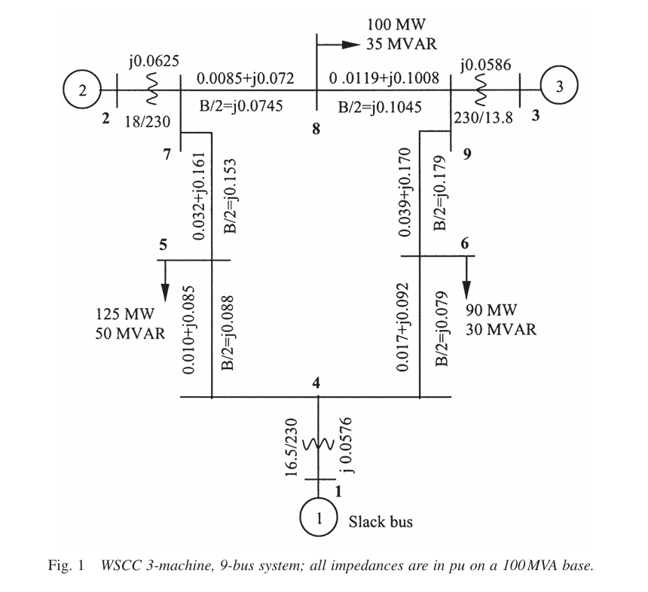
Fig 6: IEEE 9 Bus Network

The IEEE 9-bus test system is a compact benchmark model widely used for studying transient stability, power flow, and control techniques.This system represents a simple, stable and balanced three-machine network. It consists of:
- 9 buses
- 3 synchronous generators (at buses 1, 2, and 3)
- 3 generator step-up transformers
- 6 transmission lines
- 3 load buses

IEEE39 Bus System
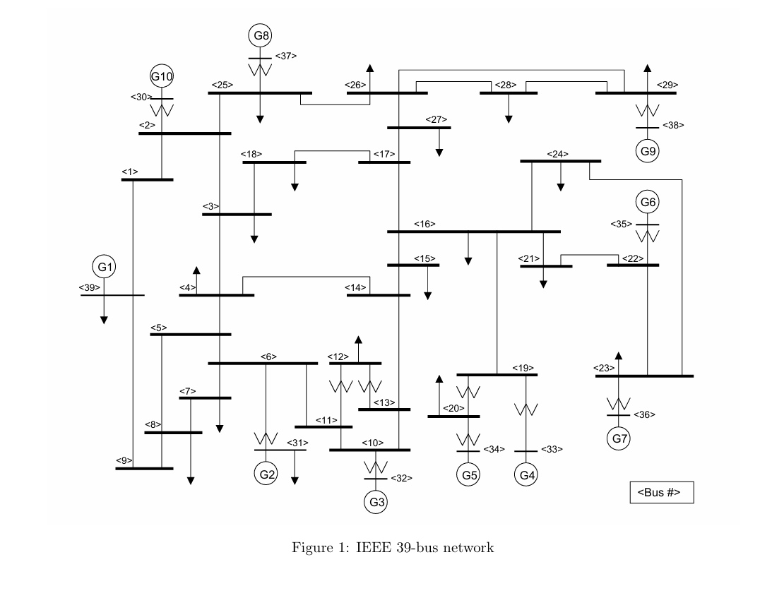
Fig 7: IEEE-39 Bus Network
The IEEE-39 bus system, also known as the New England 10-machine system, represents a medium-to-large-scale interconnected power grid. It is characterized by:
- 39 Buses
- 10 Synchronous Generators (G1 to G10)
- 12 Transformers and 46 Transmission Lines

5.2.Scope
Network Modeling:
For the development of the TEF Internal node model is developed using the constant impedance load and internal node behind the transient reactance is used followed by Kron’s reduction to show the coupling between the generators. For the development of the real system all the parameters are included.
Generator Modeling:
Disturbance Type: 3-Phase Symmetrical Fault

5.3.Software
Matlab:
MATLAB plays a crucial role in transient stability analysis by providing a flexible platform to model power system components, simulate disturbances, and solve the swing equations that describe generator dynamics. Using tools such as Simulink and Simscape Electrical, engineers can create detailed system models, apply faults, and observe the system’s response in real time. MATLAB’s numerical solvers enable accurate computation of rotor angle and speed deviations, while its visualization capabilities help evaluate system stability and determine critical clearing times. Overall, MATLAB offers an efficient and comprehensive environment for analyzing and improving the transient stability of electrical power systems.

Python:
Python is increasingly used in transient stability analysis due to its flexibility, open-source ecosystem, and powerful scientific libraries. With packages like NumPy, SciPy, and Pandas, Python efficiently solves the swing equations and performs numerical integration for multi-machine systems. Visualization tools such as Matplotlib enable clear plotting of rotor angle, speed, and power variations following disturbances, while libraries like PyPSA, GridCal, and Pandapower provide advanced power-system modeling and fault-simulation capabilities. Python also supports automation, batch simulations, optimization, and machine-learning-based stability assessment. Overall, Python offers an accessible, customizable, and cost-effective environment for comprehensive transient stability studies.

PSS/E:
PSS®E (Power System Simulator for Engineering) is a widely used industry-standard software for performing transient stability analysis and other advanced power system studies. It provides highly detailed and accurate modeling of generators, networks, controls, and protection systems, allowing engineers to simulate faults, switching events, and dynamic system behavior with precision. PSS/E includes robust numerical solvers for swing equations, extensive model libraries, and powerful scripting capabilities through Python for automation. Its reliability, speed, and comprehensive analysis tools make it a preferred platform for utilities, researchers, and grid operators in evaluating system stability and planning secure operation.

6.RESULT AND ANALYSIS

6.1.Transient Energy Function and BCU Results From MATLAB
Transient energy function framework is developed for IEEE-9 bus system using classical model consideration. Fault at different location is created and results obtained is shown in the table below:
Result 1

Fault At bus 7 at t=0 and cleared at 0.15
Result | TDS | BCU | PEBS
V | Vcl =0.843 | Vcr_BCU=0.973 | Vcr_PEBS=1.25
Critical clearing time (Tcl) | Tcl=0.15 | Tcr_BCU=0.162 | Tcr_PEBS=0.184
Computation Time | 0.14 | 0.15 | 0.12

Vcr_PEBS> Vcl
Tcr_PEBS>Tcl System is PEBS Stable

Vcr_BCU> Vcl
Tcr_BCU>Tcl System is BCU Stable

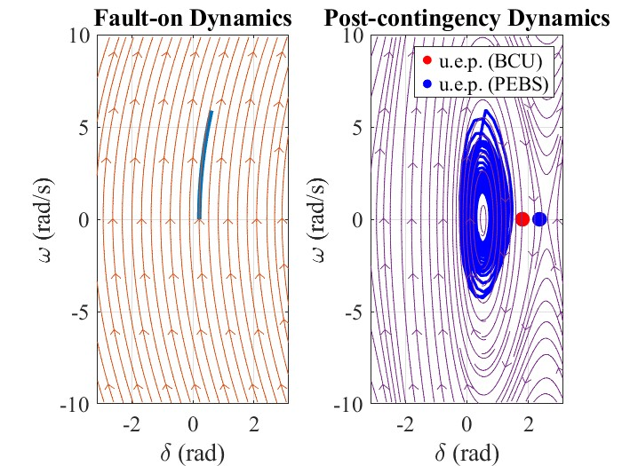

Fig 8: w vs del for faulted and Post fault Dynamics (Stable)

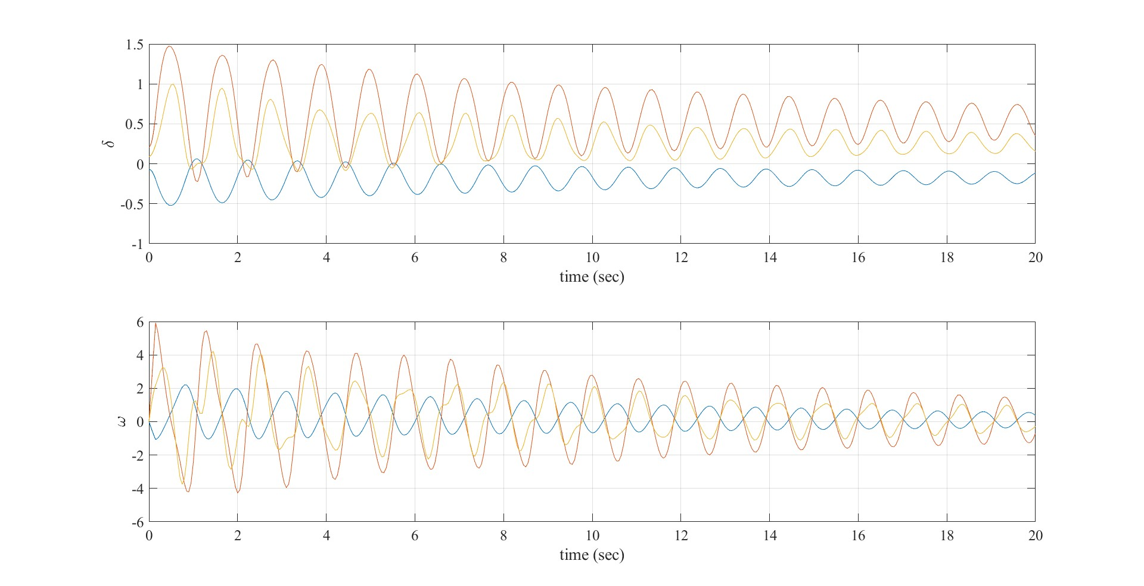
Fig 9: del vs t and w vs t for faulted and Post fault Dynamics (Stable)

Result 2
Fault At bus 7 at t=0 and cleared at 0.2
Result | TDS () | BCU | PEBS
V critical | Vcl=1.473 | Vcr_BCU=0.973 | Vcr_PEBS=1.25
Critical clearing time (Tcl) | Tcl=0.2 | Tcr_BCU=0.162 | Tcr_PEBS=0.184
Computation Time | 0.21 | 0.06 | 0.05

Vcr_PEBS> Vcl
Tcr_PEBS>Tcl System is PEBS Stable

Vcr_BCU> Vcl
Tcr_BCU>Tcl System is BCU Stable

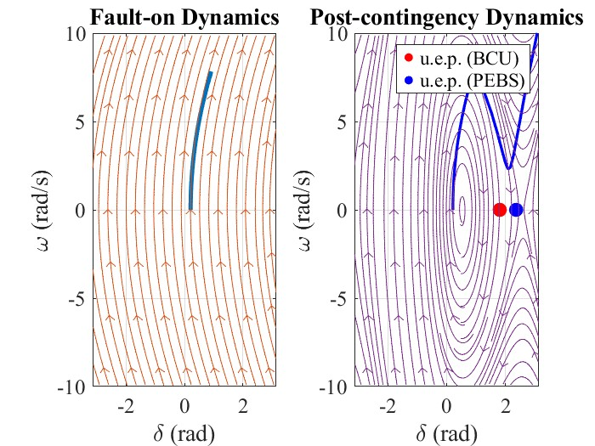

Fig 10: w vs del for faulted and Post fault Dynamics (Unstable)

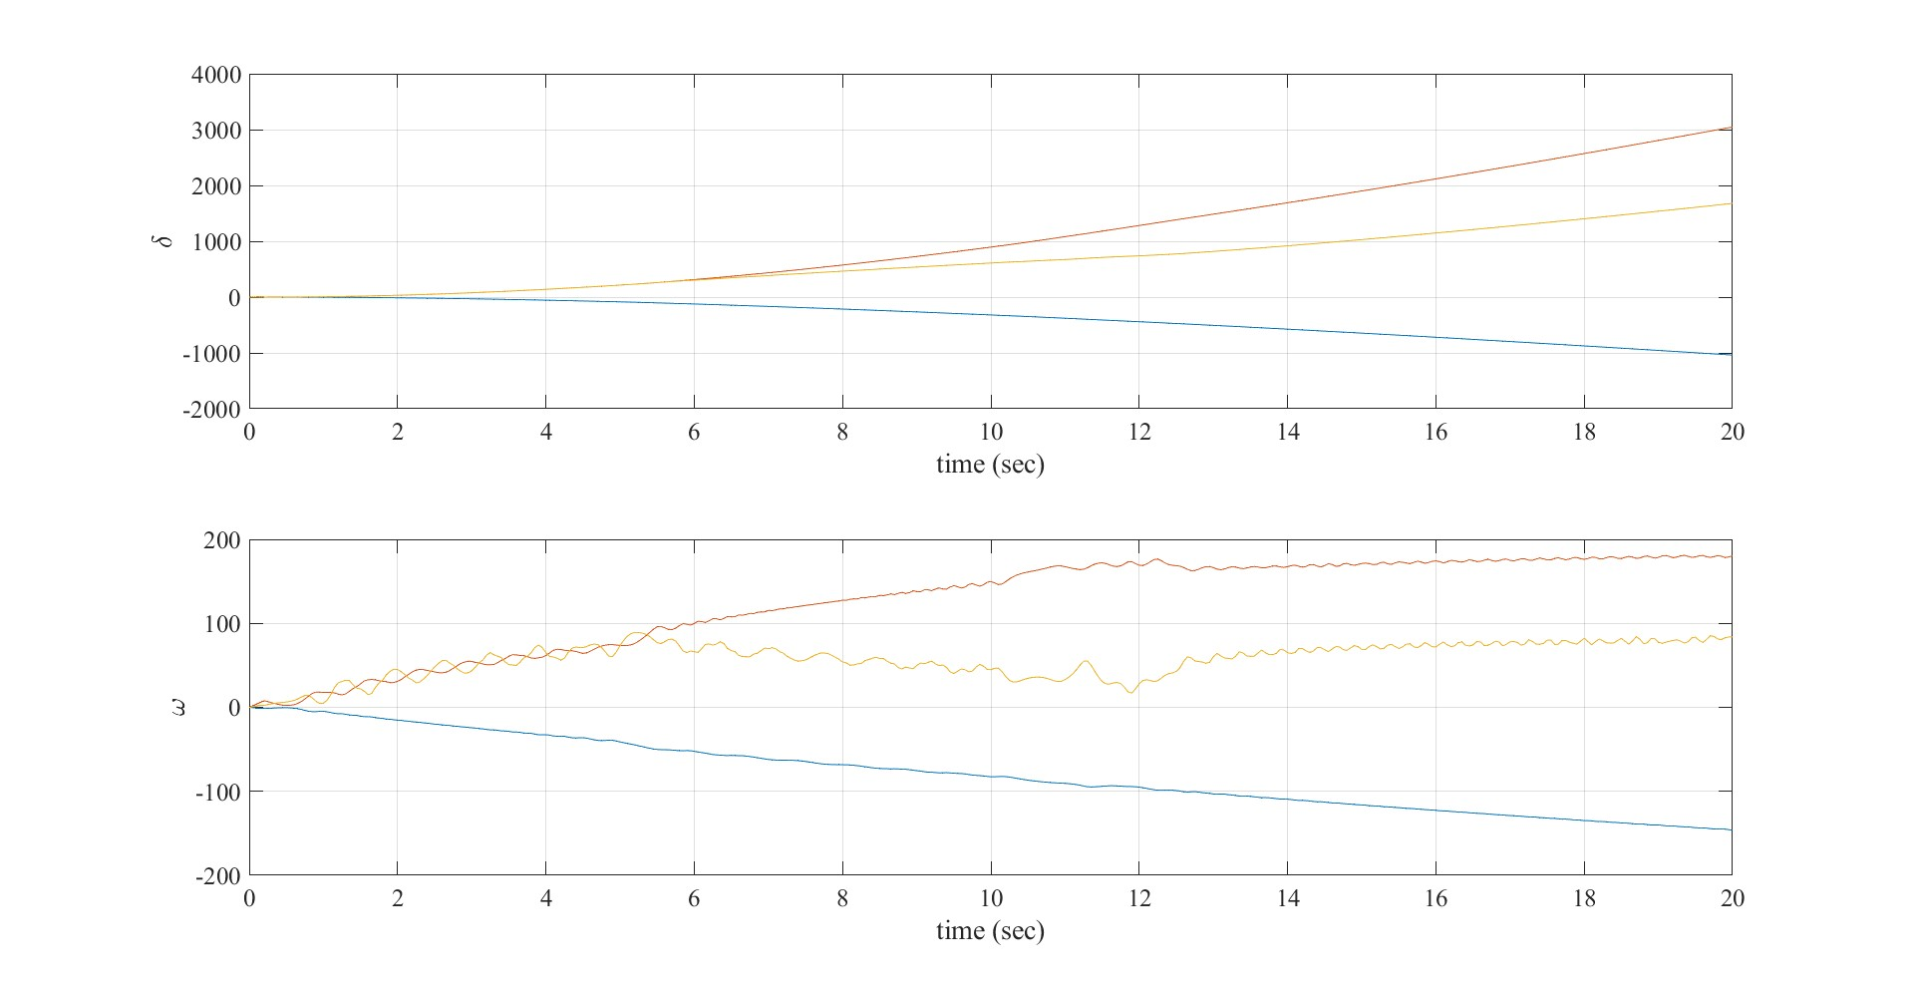
Fig 11: del vs t and w vs t for faulted and Post fault Dynamics (Unstable)

6.2.Time Domain Simulation Using PSS/E
Output 1:
Fault created at Bus 29 at t=1.0 and cleared at t=1.4
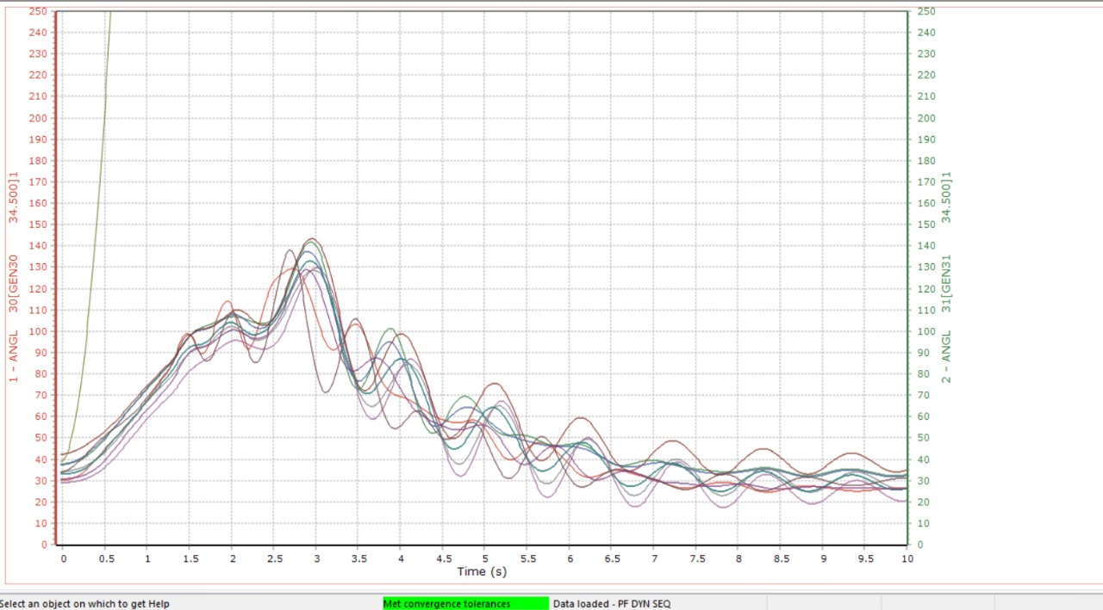
Generator[G9] goes out of synchronism
Fig 12: Plot 1[time vs rotor angle]

Output 2:
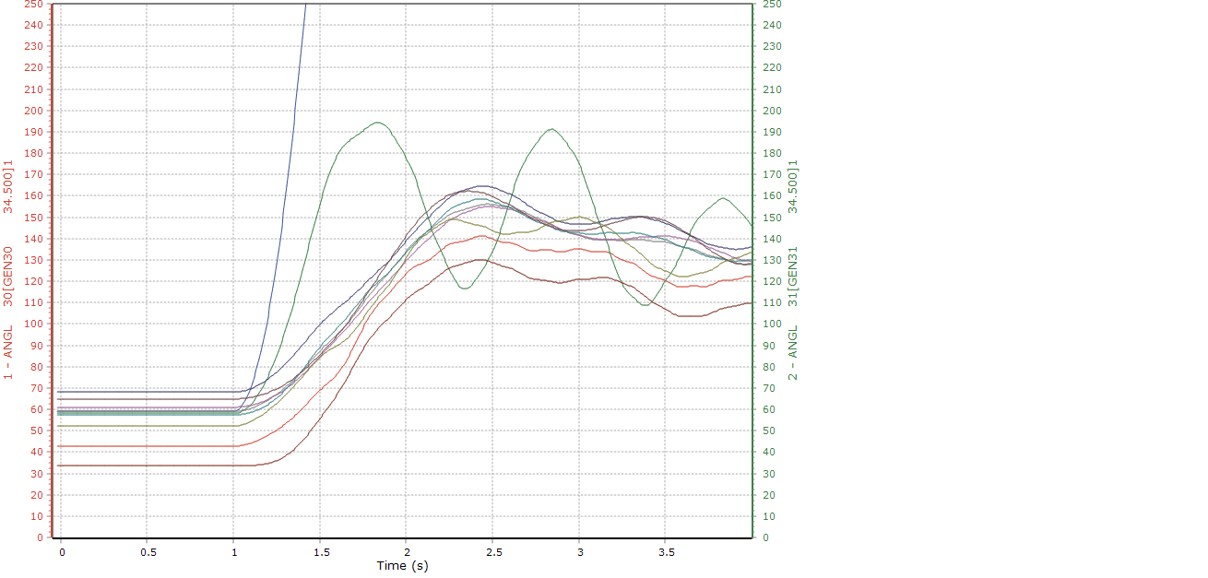
Fault created at bus 2 at t=1.0 and cleared at t=1.4. G10 goes out of synchronism.
Fig 13: Plot 2[Time vs rotor angle]
Output 3:
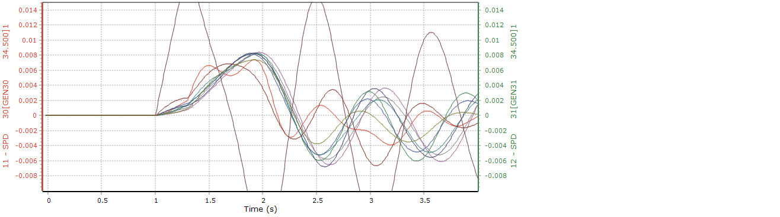
Fault created at Bus 29 at t=1.0 sec and cleared at t=1.3
Fig 14: plot 3 [time vs speed]

Output 4:
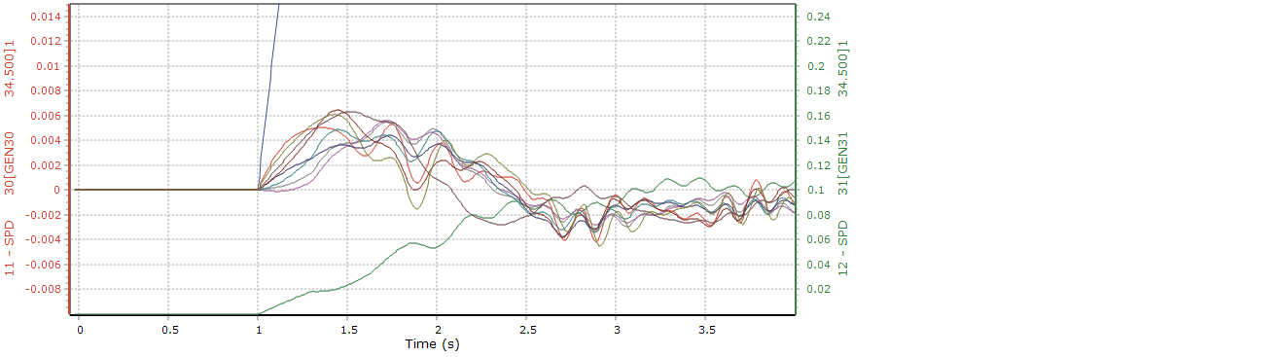
Fault created at bus 10 at t=1.0 sec and cleared at t=1.3 sec.
Fig 15: Plot 4[time vs speed]

7.REMAINING WORK

Lookup Table

LSTM

Model Training

Integration of LSTM with TEF for control action

8.CONCLUSION

9.REFERENCES
[1] P. Bhui and N. Senroy, "Real Time Prediction and Control of Transient Stability Using Transient Energy Function," IEEE Trans. Power Syst., doi: 10.1109/TPWRS.2016.2564444.
[2] F. Silva-Rodriguez, H. Raffoul, and Y. Li, “LSTM-Based Net Load Forecasting for Wind and Solar Power-Equipped Microgrids,” in Proceedings of the 2024 IEEE Power & Energy Society General Meeting (PESGM), Seattle, WA, USA, Jul. 2024, pp. 1–6. doi: 10.1109/PESGM56776.2024.1234567.
[3] G. Van Houdt, C. Mosquera, G. Nápoles, “A review on the long short term memory model,” Artificial Intelligence Review, vol. 53, pp. 5929 5955, 2020.
[4] H. D. Chiang, F. Wu and P. Varaiya, “A BCU method for direct analysis of power system transient stability,” IEEE Trans. Power Syst., vol. 9, pp. 1194–1208, Aug. 1994.
[5] P. W. Sauer, M. A. Pai, and J. H. Chow, Power System Dynamics and Stability, Second Edition. Hoboken, NJ, USA: John Wiley & Sons Ltd, 2018.

